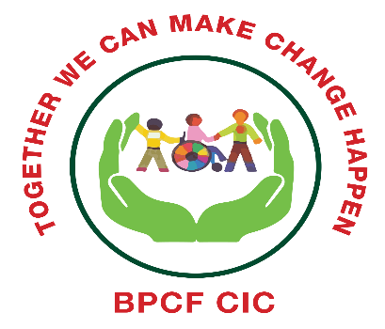

Brent Parent Carer Forum CIC
Company no 12218043

The role of a Parent Representative

Following from the launch of Brent’s SEND Strategy send-strategy-2021-25.pdf (brentyouthzone.org.uk) and the establishment of a draft action plan, we are looking for parents who have a child/YP with SEND living in Brent to sit on a number of different workstream and focus groups. Many of these groups will be meeting bi-monthly from December 21.

Role Description

The role of parent representatives is to inform decision making by talking about the lived experiences of parents and to ensure that parents’ views are fed into the planning, review, development of better services and improved processes.
Through this process, parents and professionals reach a common understanding about effective services for SEND children and Young People 0-25. Their combined information and perspectives result in joint planning that leads to more effective services

Parent reps will form part of working groups with Local Authority, Health and other interested professionals in order to plan provision and policy for SEND young people aged 0-25.

They must be able to represent the views of parents from a huge range of backgrounds whose children have a wide range of SEND needs
Partnership working
Together we can make change happen
As a Parent Carer Forum, we aim to work in a solution-focused way with our local partners to find the best possible outcomes and solutions for local families, with the resources that are available.

In order to help us achieve this, we will nominate parent reps for specific working groups. This will ensure that the parents invited represent the views of a collective body of parents, are more likely to have suitable background knowledge and are trusted to speak on their behalf.

We will allocate a minimum of three places for parents on the working group and ensure that where possible, their children be of different ages and have different disabilities. This also ensures that parents have some mutual support.

All parent representatives will be supported by the parent participation lead for SEND in Brent working as part of BPCF team.

All parent representatives will be asked to complete a feedback form after each workstream meeting to record
-main points made at the meeting.
- feedback from parents
- agreed actions for parents
- any other information

We will reward and recognise the value of Parents, Carers who contribute their time, skills and expertise to support the aims of BPCF
On submission of a feedback form Brent Inclusion service will make a small remuneration payment for parental active involvement into strategic meetings and project work.
BPCF will manage this process and make payment directly to parent reps on the Local Authorities behalf.

Parents representatives along with all others present at the meetings will act in a professional manner at meetings.

Bring issues and concerns to BPCF chair and participation worker.

To contribute meaningfully, parent reps need the same information as professionals on the working group about the purpose of the group and topics being discussed.

In order to ensure that parent reps are also knowledgeable the Participation lead will:

Make sure parent reps are on the mailing list for minutes and information

Check the best format for parents to receive the information; for example, post or email.

Identify a member of the steering group who will act as the key contact to meet with the parent reps

Keep sensitive information confidential

Code of Conduct

BPCF steering/management group members are covered by the Code of Conduct need to show integrity; ensure actions are transparent and avoid any suggestion of improper influence.

BPCF ‘Code of Conduct’ includes the findings of the Nolan Committee on “Standards in Public Life” and goes beyond these. The term ‘we’ and ‘us’ have been used throughout to show that the Code of Conduct applies to Steering / management Group Members, parent reps and staff equally.

The seven principles of public life identified by the Nolan Committee guide the content of our Code of Conduct.

- Selflessness: take decisions in terms of BPCF values and mission and not to gain financial or material benefits for ourselves, our family and friends other than in the case of universal benefit.
- Integrity: not place ourselves under obligations to individuals or organisations that might influence us in the performance of our duties.

- Objectivity: to ensure that we represent, at all times, a range of disabilities, Special Educational Needs, cultures, social backgrounds and geographical areas.
- Accountability: accept accountability for our decisions and actions to BPCF Members, the providers of public funds and other stakeholders, and submit ourselves to appropriate scrutiny.
- Openness: be open about all decisions and actions that we take. Where required give reasons for our decisions.
- Honesty: declare private interests relating to our duties and take steps to resolve conflicts arising in a way that protects BPCF’s reputation, values and mission.
- Leadership: promote and support these principles by leadership and example.
Parent representative name ____________________________________
Email ______________________________________________________
Contact details ______________________________________________
Signed ____________________________________________________
Date___________________________________

