


Brent Parent Carer Forum CIC hosts parents’ workshops in partnership with Health, Education and Social Care - dates for your dairies!

February – July 2024
Dear Parent Carer
We are pleased to let you know about several workshops we are hosting in partnership with Health, Social Care and Education.
Following on from the success of previous workshops and requests from parents to host new workshops in a number of different areas for the next year.

We add to this rolling calendar of workshops regularly . If you would like to be kept up to date about what we do, our meetings and events – become a member.
https://brentpcf.org/become-a-member/

https://chat.whatsapp.com/FkK5ph5qGXe692WsSgK6Xu
If you have any questions about any of the workshops, please email us at admin@brentpcf.org or call me on 07852101492 Carol Parent Participation Worker BPCF

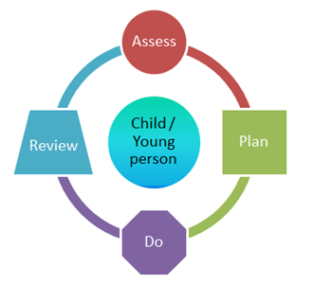
- Understanding SEND Support and the Graduated Approach
Tuesday 6th February 2024 at 10am-12noon online – daytime session Postponed new date coming soon
https://www.eventbrite.co.uk/e/understanding-send-support-and-the-graduated-approach-parents-workshop-tickets-788968374647
Tuesday 6th February 2024 at 7pm-8.30pm online – evening session – Postponed new date coming soon
https://www.eventbrite.co.uk/e/understanding-send-support-and-the-graduated-approach-evening-workshop-tickets-788985706487
Children and young people with SEN all have learning difficulties or disabilities that make it harder for them to learn than most children and young people of the same age. These children and young people may need extra or different help from that given to others
SEN support
Any support your child gets from their school or other setting should meet their needs. If your child has SEN, they will be able to access help – called SEN support – from their Early years settings, such as nurseries or childminders Support for the under 5s), schools (see section in this guide on Support for children of school age) and further education institutions (see section in this guide on Young people Aged 16 and over in further education) such as colleges and 16-19 academies.SEN support replaces school action/school action plus (in schools) and early years action/early years action plus (in early years settings).
This workshop will tell you how schools should be supporting your child and be working in partnership with you .This workshop will also provide you with suggestions of those different questions you should ask when visiting early years setting and schools.

- Understanding the Resource allocation system (RAS) in Social Care – Brent
Tuesday 27th February 2024 10-12noon
https://www.eventbrite.co.uk/e/understanding-the-resource-allocation-system-ras-in-social-care-brent-tickets-789007531767
Wednesday 6th March 2023 7-8.30pm evening session
https://www.eventbrite.co.uk/e/understanding-the-resource-allocation-system-ras-in-brent-evening-tickets-789018193657

Join this session to gain a better understanding of the RAS in Brent .
- What is RAS
- Who may be eligible
- What is the process
- How decisions are made
For children and young people who may need additional support, a Resource Allocation System provides a set of parameters or rules to be applied that allows fair allocation. In effect, RAS connects a particular level of need with a particular level of funding. This could be funding given directly to the setting or situations where young people or families have opted for a personal budget.
The decision about the level of specialist short breaks or support / care package a child/young person is eligible for is determined at the Disabled Children and Young People Panel. The panel sits weekly to decide about the level of support your child needs to achieve the outcomes which are set out in the Education Health and Care Plan/Annual review, Child in Need Plan, Short Break Plan or the Child and Family Assessment, Care and Support Plan and Preparation for Adulthood agenda.

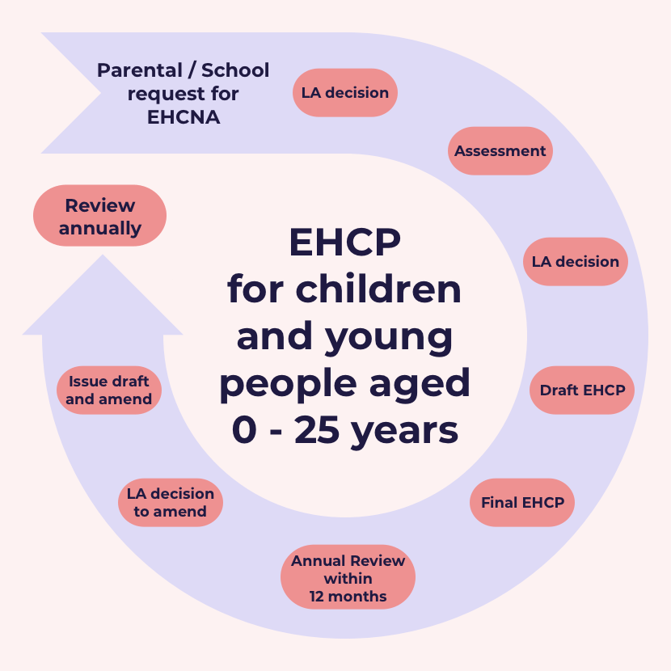

- Applying for a Needs Assessment – EHCP

Tuesday 19th March 2023 10am-12noon online
https://www.eventbrite.co.uk/e/parents-workshop-applying-for-a-ehcp-needs-assessment-tickets-789060289567

Wednesday 27th March 2024 7pm- 830pm evening online
https://www.eventbrite.co.uk/e/parents-workshop-applying-for-a-ehcp-needs-assessment-evening-session-tickets-789084632377

Some children with special educational needs (SEN) in England need more help than a mainstream school, college or nursery would normally provide at the level of SEN support
These pupils receive support through an Education, Health and Care (EHC) plan.
Children who needs are so complex may need to attend a Specialist setting which would require a EHC plan to be in place .
Join our workshop to hear in more detail about the process .
What is an EHC plan?
An Education, Health and Care (EHC) plan is a legal document that describes a child or young person’s special educational, health and social care needs, explains the extra help that will be given to meet those needs and how that help will support the child or young person to achieve what they want to in their life.
Who may need an EHC plan?
EHC plans are for children and young people whose special educational needs require more help than would normally be provided in a mainstream education setting (a college, school, nursery).
Although the plan can include health or social care needs, your child will not get a plan if they only have health or social care needs that do not affect their education.
An EHC plan can be issued to a child or young person between the ages of 0 and 25 years.
How do I get an EHC plan?
EHC plans are drawn up by the local authority after an EHC needs assessment. You, your child’s education setting or your child, if over 16, can ask your local authority to carry out an assessment.


- New Beginnings- supporting the move to big school for parents – Early Years.

Wednesday 24th April 2024 10-12 noon online

https://www.eventbrite.co.uk/e/new-beginningssupporting-the-move-to-big-school-tickets-789033529527

evening session to be confirmed.
Have you been thinking about your son/ daughter starting big school!
Starting school is an exciting time for young children and their parents. It can be a daunting time, too, especially when you son/ daughter has special educational needs and disabilities (SEND) ,with preparation and encouragement, most children will settle in easily at school.
Join us to hear how your son/ daughter with SEND will be supported to transition from home to nursery. Find out about ways you can prepare your son and daughter for their first day at school
Ask those questions that have been playing on your mind and meet the Early Years inclusion team and hear about ways to support your son/daughter and ask any questions you may have



- What is an Annual Review of an Education, Health and Social Care (EHC) plan?
Tuesday 30th April 2024 10am -12noon online
https://www.eventbrite.co.uk/e/parents-workshop-understanding-the-annual-review-process-ehcp-tickets-789103488777
Wednesday 1st May 2024 7-8.30pm on line
https://www.eventbrite.co.uk/e/parents-workshop-understanding-the-annual-review-process-ehcp-evening-tickets-789110810677

Join us to learn more about how to prepare for your son's or daughter's annual review
When a child or young person has an Education, Health and Care plan (EHC plan) there is an ongoing requirement for the EHC plan to be reviewed by the local authority at least annually. This is referred to as the Annual Review. In Early Years an EHC plan should be reviewed every 3 to 6 months (CoP 9.178).
The Annual Review is more than just a review meeting, it is a process that must be completed on or before the anniversary of when the EHC plan was first issued or the anniversary of the last review. An Annual Review must be undertaken in partnership with the child and their parent or the young person, and must take account of their views, wishes and feelings, including their right to request a Personal Budget.



- Young person’s transition annual review.

Tuesday 7th May 2024 10am -12noon

https://www.eventbrite.co.uk/e/bpcf-parents-workshop-young-persons-transition-annual-review-tickets-789119837677

Wednesday 8th May 2024 7pm -8.30pm

https://www.eventbrite.co.uk/e/fbpcf-parents-workshop-young-persons-transition-annual-review-evening-tickets-789124461507

Join us to learn more about the purpose and importance of your Son/Daughter's Annual Review at year 9 – transition.
Transition review
The LA must conduct a ‘transition review’ when the child or young person is transferring from one stage of education to another. This is to ensure the EHCP accurately describes the child or young person’s needs and provides the support they will require in their next placement. It also gives the child or young person and their parents an opportunity to raise any concerns they may have.
The process and timescales for EHCP reviews are outlined in the SEND Regulations 2014. Taking these into account, the review meeting should be early in the autumn term - ideally no later than October. Parents must be given at least two weeks’ notice of the meeting date.
The person arranging the meeting must request advice and information about the pupil from parents, the school, the local authority, and healthcare and social services professionals (if appropriate). For the transfer review, it’s also a good idea to have updated assessments from therapists or specialist teachers working with the pupil.
J﻿oin us and hear more about the importance of this review and have an opportunity to have any questions answered.
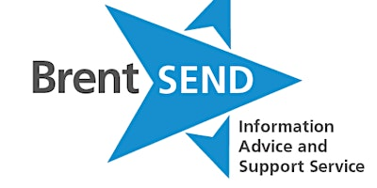
- The Role of SENDIASS
Tuesday 14th May 2024 10am -12noon online
https://www.eventbrite.co.uk/e/the-role-of-sendiass-tickets-789130920827
Tuesday 21st May 2024 7pm -8.30pm on line
https://www.eventbrite.co.uk/e/the-role-of-sendiass-tickets-789142435267

SENDIASS stands for Special Educational Needs and Disabilities Information Advice and Support Service.
It’s a free, impartial, and confidential service offering information to young people with special educational needs and disabilities (SEND) and to their parents and carers.
There is a SENDIAS Service in every local authority in England.
Join us and meet the team and hear how they can support you .

9. How to ask the right questions – to get the best results !
How to challenge effectively

Tuesday 11th June 2024 10-11.30am online
https://www.eventbrite.co.uk/e/-how-to-challenge-effectively-to-create-better-outcomes-for-your-children-tickets-789154972767

Wednesday 12th June 2024 708.30pm online

https://www.eventbrite.co.uk/e/how-to-challenge-effectively-to-create-better-outcomes-for-your-children-tickets-789162094067
Every day we are faced with situations where our point of view can be challenged. Being able to present your ideas, and work with others with opposing views. It takes confidence to challenge others. Thinking through your approach can help reduce nervousness about challenging someone and give you a different perspective.

Join us and a member of the SENDIASS TEAM to hear about ways to challenge differences and effectively challenge decisions and situations



- Money Matters- a guide to welfare benefits workshop – day time

Tuesday 18th June 2024 10-12noon online

https://www.eventbrite.co.uk/e/bpcf-money-matters-guide-to-benefits-workshop-day-time-tickets-789173528267

Tuesday 18th June 2024 7-8.30pm online

https://www.eventbrite.co.uk/e/bpcf-money-matters-guide-to-benefits-workshop-evening-session-tickets-789188131947

Join Brent Hubs to find out about benefits you may be entitled too!
Find information about financial support for individuals with special educational needs and disabilities and their carers.
What can money matters help you with? There's a range of information and support services available to help you make sure you are making the most of your money. This includes information on budgeting, saving, debt prevention, affordable credit, benefit entitlement, moving from benefits into employment and energy best deals.
All disability benefits. Links to Universal Credit
Changes to benefits when a disability young person turns 16 www.brent.gov.uk I www.brenthubs.com

11.Understanding and managing Behaviours that may challenge ?
Tuesday 2nd July 2024 10-12pm online
https://www.eventbrite.co.uk/e/understanding-and-managing-behaviours-that-may-challenge-tickets-795383311897
Wednesday 3rd July 2024 7-8.30pm online
https://www.eventbrite.co.uk/e/understanding-and-managing-behaviours-that-may-challenge-eve-session-tickets-795394415107
As all children grow up there are times when they show difficult or inappropriate behaviour.
Understanding the function of the behaviour that challenges When to intervene to stop the behaviour
When is it safe to leave the child/young person to calm?
What are proactive and reactive strategies?
Is there anything else I can do?
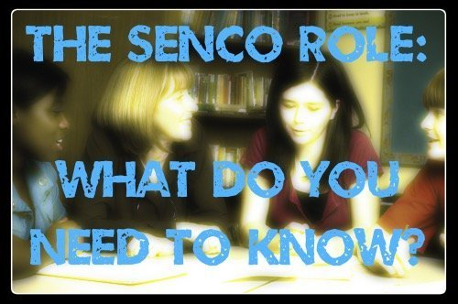
11. The Role of the SENCO – Special Educational Needs Coordinator
Details coming soon to be kept up to date join BPCF Become a member – BRENT PARENT CARERS CIC (brentpcf.org) or email admin@brentpcf.org
Join us to find out more about the role and responsibilities of the SENCO
The SENCO has a critical role to play in ensuring that children with special educational needs and disabilities within a school receive the support they need.
Gradually over the years the status and import of the role has developed with successive guidance validating and substantiating the role.
In the most recent Code of Practice, the SENCO must be a qualified teacher (why ever were they not!) and a newly appointed SENCO must achieve a National award in Special Educational Needs Coordination within three years of appointment.
The SENCO has ‘an important role to play with the headteacher and governing body in determining the strategic development of SEN policy and provision and will be most effective if they are part of the school leadership team’.
If you have any questions or have suggestions and requests for other workshops
please email admin@brentpcf.org
Coming soon - more details to follow !
- Understanding Mental Capacity, lasting power of attorney and appointeeship
- When to start, and what to consider and how to prepare for the transition from early years to primary school .
- The role of Social Care
- When to start and what to consider and how to prepare for the transition from primary to secondary school.
- Cost of living – where to go for support and advice.
- Early Intervention – understanding the Thrive model.
- Sleep hygiene
- Introduction to Brent Family wellbeing centres
- The role of health therapists
- Toilet training
- Preparing for adulthood part 1 & 2
- Dental Hygiene and healthy eating

