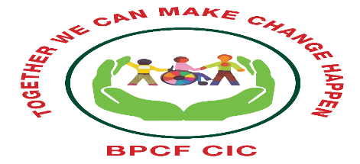
Brent Parent Carer Forum
Community Interest Company
Company No: 12218043
Together we can make change happen

Coffee and Chat SEND drop in Mornings

.
Does your child have Special Educational Needs and/or Disabilities (SEND)?
You are warmly welcome to drop on Tuesdays
Starting Tuesday 23rd January 2024 10-30-12pm
Young Brent Foundation
ACAVA
Unit 8 (ground floor)
Barham Park- 660 Harrow Road
HAO2HB.
Your involvement, views and voice are important.
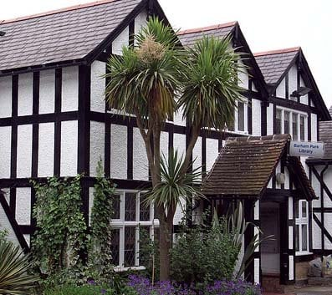
(the door bell doesn’t work sometimes so if we don’t answer give us a call 07305145167)

